**FINDING MISSING PERSON USING AI**

**Using Deep Learning**

**Team-10**

### Developed By: Rishabh Raj, Manoj Kumar B T, Manohar R, Karthik T T

**Smart Bridge-Remote Summer Internship Program**

# INTRODUCTION

A deeply disturbing fact about India’s missing children is that, while on an average 174 children go missing every day, half of them remain untraceable. The National Crime Records Bureau (NCRB) report which was cited by the Ministry of Home Affairs (MHA) in the Parliament (LS Q no. 3928, 20–03–2018), more than one lakh children (1,11,569 in actual numbers) were reported to have gone missing till 2016, and 55,625 of them remained untraceable till the end of the year. The statistics are however, indicative of the absence of a national Missing Children’s repository. “There are no budgets earmarked for tracking missing people,” said an official source.

Missing person identification and tracking can be done using intelligent video surveillance systems. Due to some reason, the people leave the home or some child or old men forget the route of their home. To this missing case, entry is updated in police station. By using CCTV camera technology, compare each person with the available database and find these people.

One of the most interesting areas of human computer interaction is face detection and tracking. Distinguishing facial features are comparatively low and it is most interesting task to observe these. Detection and tracking face objects from video is a challenging task. Finding a missing person case can be one of the most challenging assignments handled in one’s career. The officer responding to a missing person call is in many cases responding to a situation where the reason for an individual’s disappearance is unknown. A face is the best way to detect and recognize a person. No recognition algorithms will work without face detection step. Rate of detection affects the recognition stage. With all these, noise is a very difficult task to detect and localize an unknown non-face from still image or video image. Face detection and recognition in surveillance applications is still a challenging task since face images may be affected by changes in the scene, such as pose variation, face expression, or illumination. The main goal to propose this system is to find the missing person with the help of CCTV camera video input and report their location to the police station and also relatives of that specific person. A face recognition technique which is used here to matches the train face image to the original face image. CNN is used in this system which is capable of authenticating a person identity by his or her face scan. The proposed approach is simple, efficient, and accurate. This system gives accurate result as compare to existing approach. System plays very important role in authentication and verification related field. That is this gives important result very quickly i.e. finds the missing person soon as compare to traditional methods.

## Overview

Deep-learning based techniques and methods are becoming popular in face detection and recognition, as their performance is superior in image analysis fields, such as object detection, image classification and semantic segmentation. Deep learning techniques have achieved state of-the-art performance for automatic segmentation of faces through multi-model image sensing. The Convolutional Neural Network (CNN) is a powerful method for face recognition and prediction. However, CNN is mostly used for image segmentation, classification, and prediction of faces of different persons. More deep-learning based methods that are utilized for image segmentation, classification, and prediction and by using the algorithm of a Flask model has been implemented and tested. Among all the deep learning methods and techniques, CNNs perform better for image segmentation, classification, and prediction.

## 1.2 Purpose

Our aim from the project is to make use of NumPy, Pandas, Matplotlib, TensorFlow, & Keras libraries from python to extract the libraries for deep learning for the face detection and recognition.

Secondly, to compare the person in the CCTV with the image of the missing person stored in the database.

And in the end, if the missing person is detected, to send a message to the police station containing the location of that person.

# 2. LITERATURE SURVEY

The primary goal is to recognize location of faces from video. Moreover, finding face motion leads to be a part of face recognition system. Firstly, face edges are detected using Robert edge detector followed by a set of arithmetic operations between an initial frame and the nearest ones. Thereafter, non-desired edges and noise are removed by Gaussian filtering technique. A logical operation is then performed between the previous two output frames and noiseless face contour frame for detecting edges corresponding to face video. Finally, four corner points i.e. top-left, top-right, bottom-left, bottom-right is computed to draw rectangle around the face and detect face contour of each frame. To track human face from video, scalar and vector distance between four corner points of two consecutive frames are calculated. Displacement of corner points means position and location of face changes in the next frame.

It presented for automatic detection and recognition of human faces for surveillance purpose. The proposed method first detects skin regions in the image using a skin color model using YCbCr and HSV color space. Then apply height to width ratio followed by face region identification. Lastly PCA verification algorithm is used to detect face accurately. Train face images are used to generate feature space (face space). Test images are then projected on sub spaces and distances measured to find out best match from train images. The face space is affine subspace and face images can be represented as weighted sum of these sub spaces.

**2.1 Existing Problem**

Due to some reason, the people leave the home or some child or old men forget the route of their home. To this missing case, entry is updated in police station. A deeply disturbing fact about India’s missing children is that, while on an average 174 children go missing every day, half of them remain untraceable. The National Crime Records Bureau (NCRB) report which was cited by the Ministry of Home Affairs (MHA) in the Parliament (LS Q no. 3928, 20–03–2018), more than one lakh children (1,11,569 in actual numbers) were reported to have gone missing till 2016, and 55,625 of them remained untraceable till the end of the year. The statistics are however, indicative of the absence of a national Missing Children’s repository. “There are no budgets earmarked for tracking missing people,” said an official source.

## 2.2 Proposed Solution

### Deep Learning (CNN):

To build an algorithm which automatically identifies whether the person shown up in the CCTV is a missing person or not. If he is the one, then the location of that person should be sent to the police station, so that, the police can track him using that location. In this firstly, we train the machine with some of the specified images of the missing person provided during the entry of the case in the police station. Then the user (police) will get a message containing the location of the missing person automatically, whenever the missing person shown up in the CCTV camera.

# 3. THEORETICAL ANALYSIS

It is important to detect the face of the missing person using CCTV. Manual detection of a face is a tiresome task and involves human error, and hence computer-aided mechanisms are applied to obtain better results as compared with manual detection systems. In **deep learning**, this is generally done by extracting features through a convolutional neural network (**CNN**) and then classifying using a fully connected network.

We have trained a convolutional neural network and obtained a prediction accuracy of up to 80%. CNN is a modified variety of deep neural net which depends upon the correlation of neighbouring pixels. It uses randomly defined patches for input at the start, and modifies them in the training process. Once training is done, the network uses these modified patches to predict and validate the result in the testing and validation process. Convolutional neural networks have achieved success in the image classification problem, as the defined nature of CNN matches the data point distribution in the image. As a result, many image processing tasks adapt CNN for automatic feature extraction.

**3.1 Block Diagram**

**Video Streaming And Informing**

**Data Collection**

Use API Documentation To Send Message

OpenCV For Video Processing

Optimize and save the model

Adding Dense Layers

Train and Test the Model

Configure Learning Process

Adding CNN Layers

Initializing the Model

Importing the Model Building Libraries

Apply ImageDataGenerator Functionality to Trainset and Testset

Configure ImageDataGenerator Class

Import the ImageDataGenerator Library

Create Train and Test Folders

**Data Preprocessing**

**Model Building**

## 3.2 Software Designing

* Jupyter Notebook Environment
* Spyder IDE
* Deep Learning Algorithms
* Python (Sequential,Dense,Conv2D,MaxPool2D,Flatten)
* OpenCV

We developed this “Finding Missing Person project” by using the Python language which is a interpreted and high level programming language and using the Deep Learning algorithms(CNN). For coding we used the Jupyter Notebook environment of the Anaconda distributions and the Spyder, it is an integrated scientific programming in the python language. API Documentation is used to send the message along with name and location of the missing person to the police station, whenever he is shown up in the CCTV.

# 4. EXPERIMENTAL INVESTIGATION

In our project, we have used our own images(faces) as Dataset. This dataset contains two folders: test set and training set. In test set folder, we have 2 or more categories. Each category has the images of a particular person and the each category is named after the names of the face of person it contains. Similarly, in the training set folder. Having 160 images belonging to 2 classes in training set and 40 images belonging to 2 classes in test set(for 2 categories).

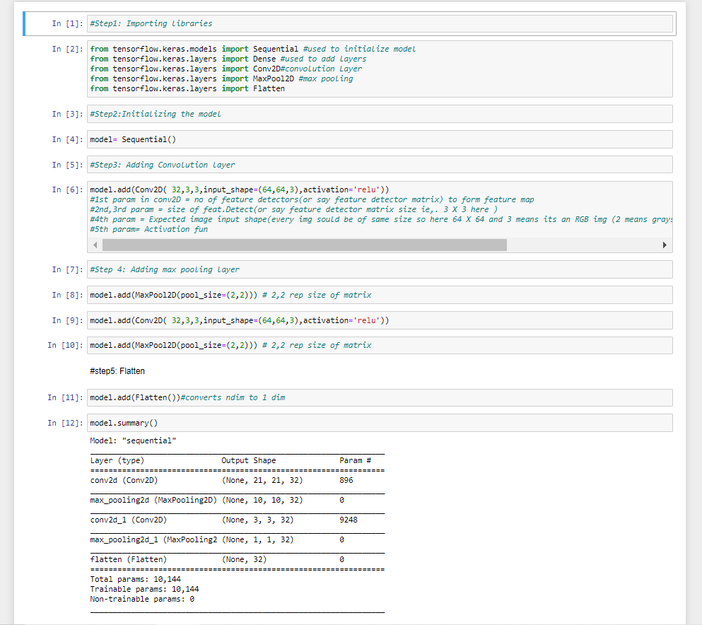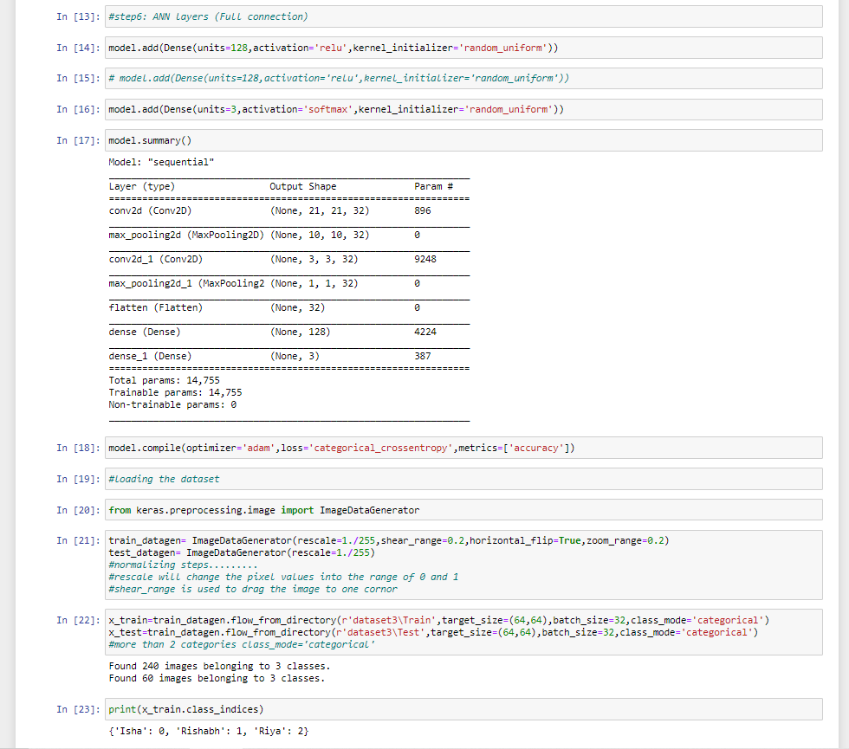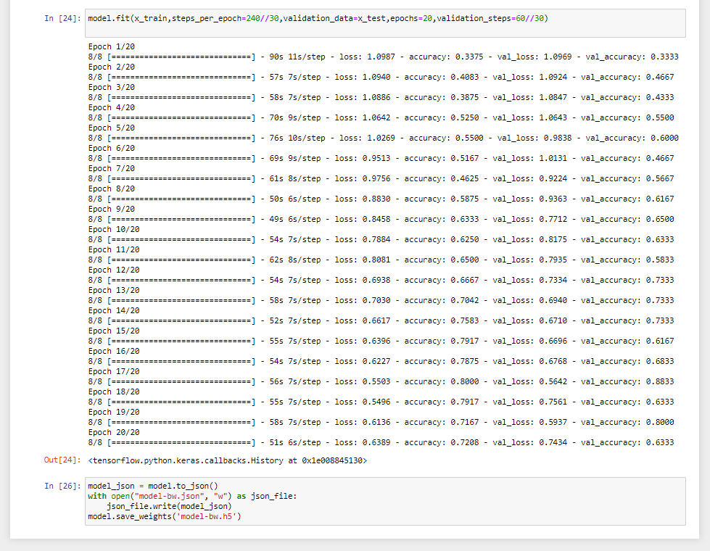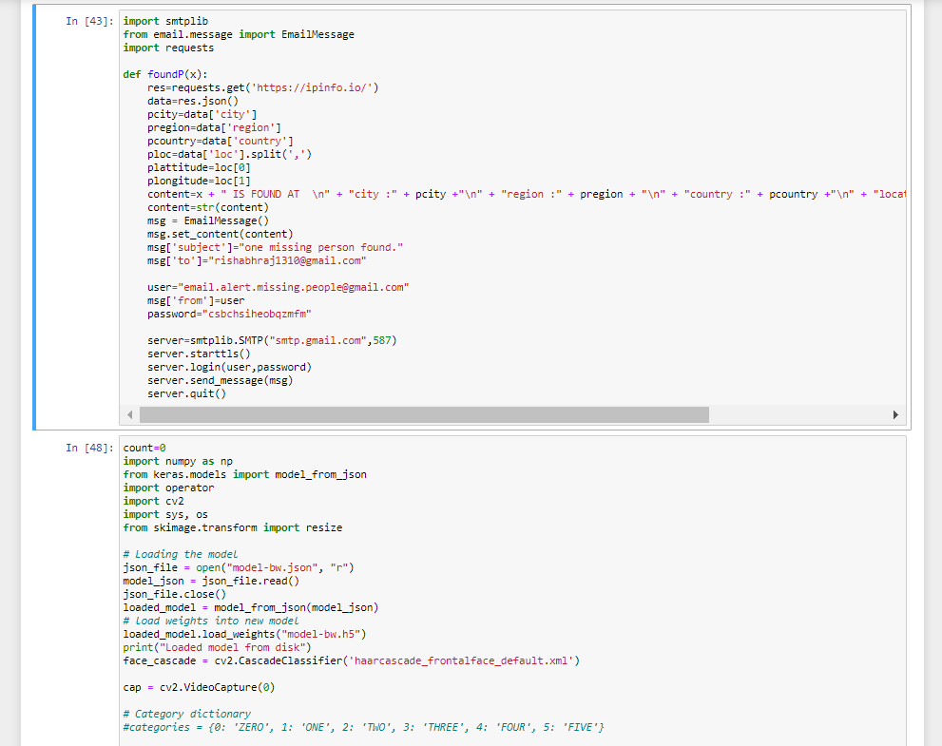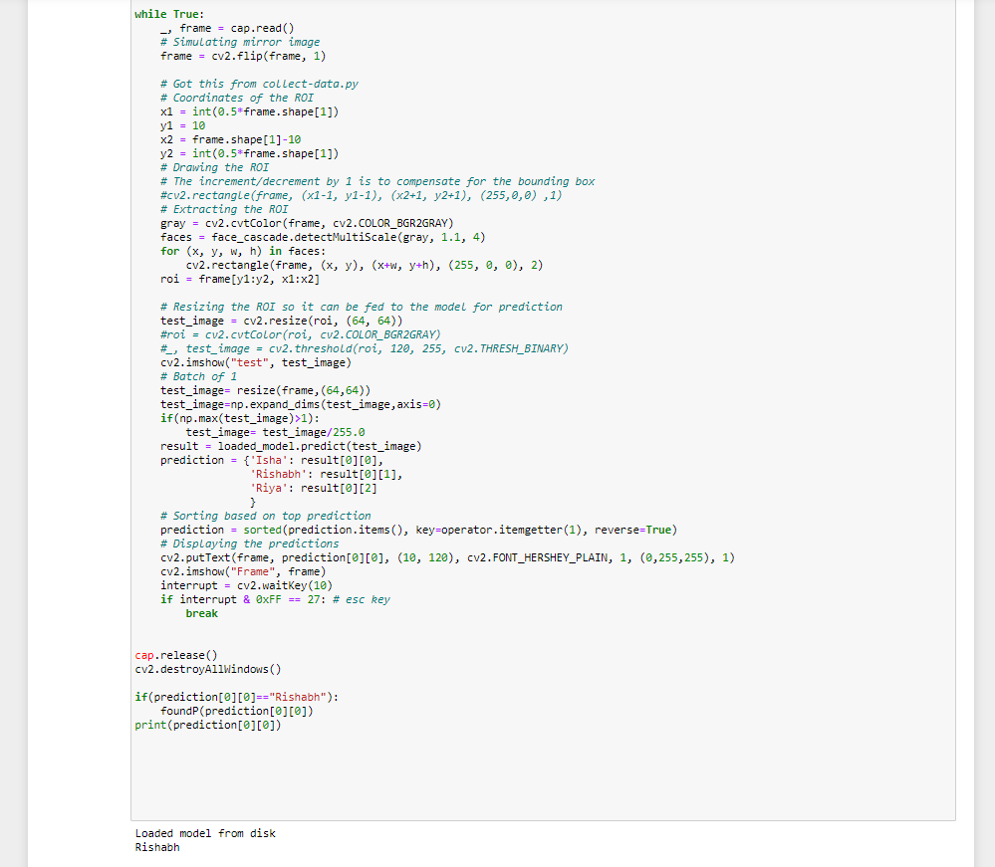

1. **FLOW CHART**

START

DETECT THE FACES TO DO PREDICTION

DATABASE

DEEP LEARNING ALGORITHM LIKE CNN

DESIGNED MODEL

DECISION

NOT A MISSING PERSON

MISSING PERSON

SEND MESSAGE TO THE POLICE STATION

STOP

**SYSTEM ARCHITECTURE**

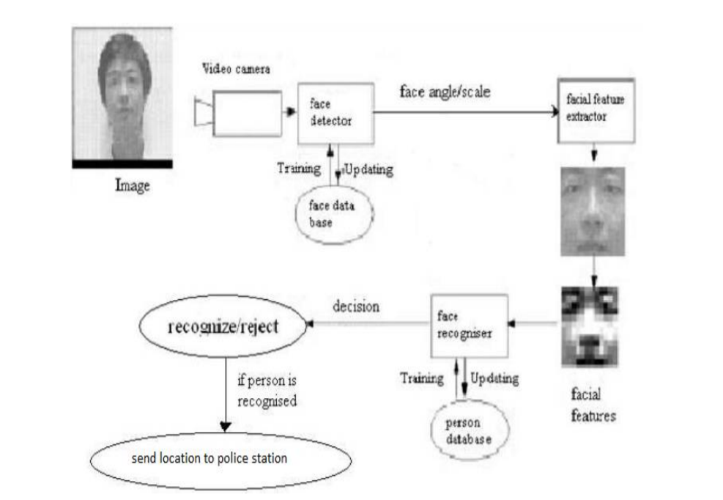

# 6. RESULT

In this paper, the CNN algorithm is used to predict the face of a person. The obtained results are displayed in Table below. The results shows that, the performance of the model is displayed as well as the accuracy on predicting the face of a person are mentioned in it respectively.

|  |  |
| --- | --- |
| **Algorithm used** | **Accuracy** |
| CNN | 80% |

# 7. ADVANTAGES AND DISADVANTAGES

### Advantages:

* We are able to detect faces of missing person through a CCTV, so that it would be of great help to the police team to track that person.
* It could bring a whole new dimension in security by tracking faces from CCTV in real-time.
* Missing person face detection is easy to implement and understand.
* It operates in real-time due to low time complexity.
* It is applicable in training and test-time.
* Deliver invariance with respect to the lesion position, scale, and rotation.
* Additionally, it can be also used to track the criminals using CCTV in real-time.

### Disadvantages:

* With all the noise(presence of multiple faces) in the CCTV input video, still it is difficult to detect and identify an face of a missing person.
* It is still a challenging task, since face images may be affected by changes in the scene, such as pose variation, face expression, or illumination.
* There will be a need of good amount of face images of the missing person while training the model.

**8. APPLICATIONS**

* “Finding missing person using Convolutional Neural Networks” simplifies the management process of tracking down a missing person manually by police.
* Surveillance applications.
* Works in Real- Time.
* Security and authentication applications.
* Fast processing and immediate results with high security.
* Minimizing human effort and cost efficient databases.

# 9. CONCLUSION

Identification of a person in surveillance area using face information has many applications in real life. The face recognition in the images got from surveillance camera is challenging task due to the presence of multiple faces in the given area. In this paper a method has been proposed where the algorithm has been modified for the detection of the faces, extraction of the feature information and matching the features. The work can further be extended for improving the recognition accuracy as well as time for large face databases. This system is designed to find the missing people. If the missing person found in the CCTV Video streaming, then track the location of missing person. After missing person found in the CCTV Video streaming, then send location SMS to relatives of missing person and Police station. So our system can perform the very important role in security and authentication issues.

# 10. FUTURE SCOPE

There is a wide scope for future implementation of “Finding Missing Person using Convolutional Neural Networks” towards an interesting experience of modern Technologies. Digital Platform is ‘one stop shops’ for all kinds of Naturalists to serve the domestic and international users at any time, any moment and anywhere in any parts of the world. In future the CNN algorithm can be applied on other data sets available for face detection to further investigate its accuracy. A rigorous analysis of other deep learning algorithms other than this can also be done in future to investigate the power of deep learning algorithms for face prediction. In further study, we will try to conduct experiments on larger data sets or try to tune the model so as to achieve the state-of-art performance of the model, in such a way that all the small kind of identification can be done easily and a great UI support system making it complete web application model.

# 11. BIBLIOGRAPHY

1. Aniruddha Dey, “A Contour based Procedure for Face Detection and Tracking from Video” 3rd Int'I Conf. on Recent Advances in Information Technology I RAIT-20161.

2. Andreas Ess, Bastian Leibe, Konrad Schindler, Luc Van Gool, “A Mobile Vision System for Robust Multi-Person Tracking ”978-1-4244-2243- 2/08/$25.00 ©2008 IEEE.

3. Rolf H. Baxter, Michael J. V. Leach, Sankha S. Mukherjee, and Neil M. Robertson, “An Adaptive Motion Model for Person Tracking with Instantaneous Head-Pose Features ” IEEE SIGNAL PROCESSING LETTERS, VOL. 22, NO. 5, MAY 2015.

4. He Guohui, Wang Wanying, “An algorithm for fatigue driving face detection and location” 2015 8th International Conference in Intelligent Computation Technology and Automation.

5. K. V. Arya, Abhinav Adarsh, “An Efficient Face Detection and Recognition Method for Surveillance ” 2015 International Conference on Computational Intelligence and Communication Networks.

6. Pranti Dutta, Dr. Nachamai M, Department of Computer Science, Christ University Bengaluru, India “Detection of Faces from Video Files with Different File Formats”.

7. Lihe Zhang, Huchuan Lu, Dandan Du, and Luning Liu, “Sparse Hashing Tracking” IEEE TRANSACTIONS ON IMAGE PROCESSING, VOL. 25, NO. 2, FEBRUARY 2016.

8. Dennis Mitzel, Esther Horbert, Andreas Ess, and Bastian Leibe, “ Multi-person Tracking with Sparse Detection and Continuous segmentation ”.

9. Francesco Comaschi, Sander Stuijk, Twan Basten , Henk Corporaal, “ROBUST ONLINE FACE TRACKING-BY-DETECTION ”.

10. Xiaoming Liu and Tsuhan Chen, “Video-Based Face Recognition Using Adaptive Hidden Markov Models ” Electrical and Computer Engineering, Carnegie Mellon University, Pittsburgh, PA, 15213, U.S.A.

11. International Journal of Innovative Research in Computer and Communication Engineering (An ISO 3297: 2007 Certified Organization) (Website: www.ijircce.com) (Vol. 5, Issue 3, March 2017).